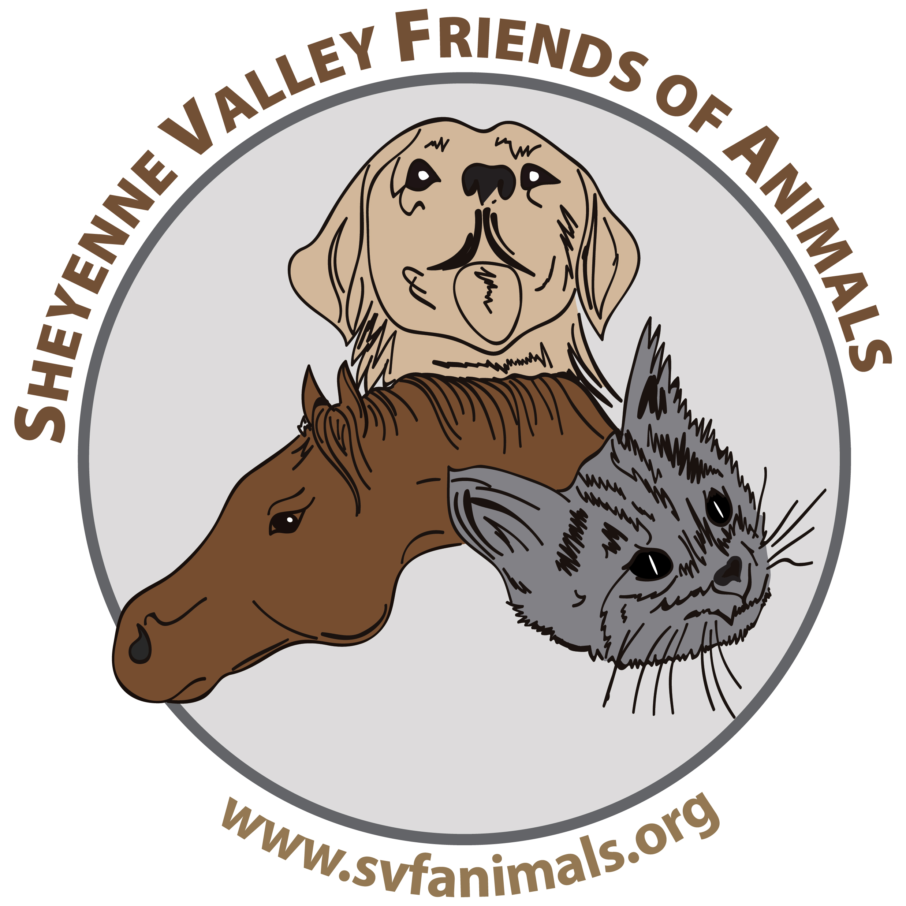
Pre-Adoption Form
Sheyenne Valley Friends of Animals
P.O. Box 432 Valley City, ND 58072
Adoption fees: Dog - $75; Cat - $50
Note: We do not adopt out pets on a first-come, first-served basis. We look for the best possible placement and work toward adoptions that will result in a permanent, loving home for the animal.

Name:_______________________________________________

Address:_____________________________________________

City:___________________________ State:_______________ Zip Code:____________

Daytime Phone:_______________________ Evening Phone:_______________________

Email Address:_____________________________________

Where/how did you hear about this animal? _______________________________

Type of home you live in: ___Farm/rural property, ___House, ___Apartment, ___ Mobile Home
Do you ___Rent or ___own?

If rent, do you have your landlord’s permission to have a pet? ___Yes ___No
Landlord’s name and contact info: ___________________________________________________

Do you want to adopt a Cat or dog? ___Cat ___Dog A specific breed? _________________
Are you interested in an animal available now through SVFA? Which?________________
How many adults live in your household?_______

How many children live in your household and their ages?_________________________________

Who would be the pet’s primary caregiver?______________________________________________

What other pets do you have at this time?________________________________________________

List all pets you have had in the past 10 years and what happened to them:____________________
____________________________________________________________________________________
____________________________________________________________________________________

Would this pet live ___indoors, ___outdoors, or ___indoors and outdoors?

(Note: Animals will not normally be adopted out to homes where they will be kept outside.)

Where would the pet spend the day? ___Fenced Backyard, ___Basement, ___Garage,

___Crated in House, ___In House (restricted rooms), ___Other (explain)_____________________

___________________________________________________________________________________

Where would the pet spend the night? ___Fenced Backyard, ___Basement, ___Garage,

___Crated in House, ___In House (restricted rooms), ___Other (explain)_____________________

____________________________________________________________________________________

How many hours daily would pet be left alone?____________

How would the pet be exercised and how often?___________________________________________

Would you object to a home visit prior to finalizing the adoption? _______Yes _______No

Please provide two (non-veterinary) references:

1. Name:___________________________________________

Address:_________________________________________________________________________

Phone:_________________________ Best time to be reached ____AM ____Afternoon _____Eve

2. Name:____________________________________________

Address:__________________________________________________________________________

Phone:_________________________ Best time to be reached ____AM ____Afternoon _____Eve

BY SUBMITTING THIS APPLICATION, I UNDERSTAND THAT COMPLETING THIS APPLICATION DOES NOT GUARANTEE THAT ANY ANIMAL(S) WILL BE ADOPTED TO ME.
I ALSO CERTIFY THAT I HAVE BEEN WHOLLY AND COMPLETELY TRUTHFUL AND HAVE NOT CONCEALED OR WITHHELD ANY INFORMATION.
I HEREBY AUTHORIZE THE SHEYENNE VALLEY FRIENDS OF ANIMALS TO VERIFY ANY INFORMATION GIVEN BY ME AND/OR TO INVESTIGATE MY APPLICATION HOWEVER THEY SEE FIT.
I UNDERSTAND THAT THE SHEYENNE VALLEY FRIENDS OF ANIMALS IS A RESCUE AND REHOMING PROGRAM AND NOT A REFERRAL SERVICE.

I AGREE TO PROVIDE APPROPRIATE FOOD AND SHELTER FOR ANY ADOPTED PET AND TO PROVIDE ALL NECESSARY VACCINATIONS AND MEDICAL TREATMENT NECESSARY TO ENSURE THE GOOD HEALTH OF THE ADOPTED PET.

If the animal you are applying for is placed in a home more suitable for the animal, you will be notified by email or by phone.

Signature:_______________________________________________ Date:________________

Signature of SVFA official _________________________________
01/12

Return to SVFA, PO Box 423, Valley City, ND, 58072 or email to info@svfanimals.org.

