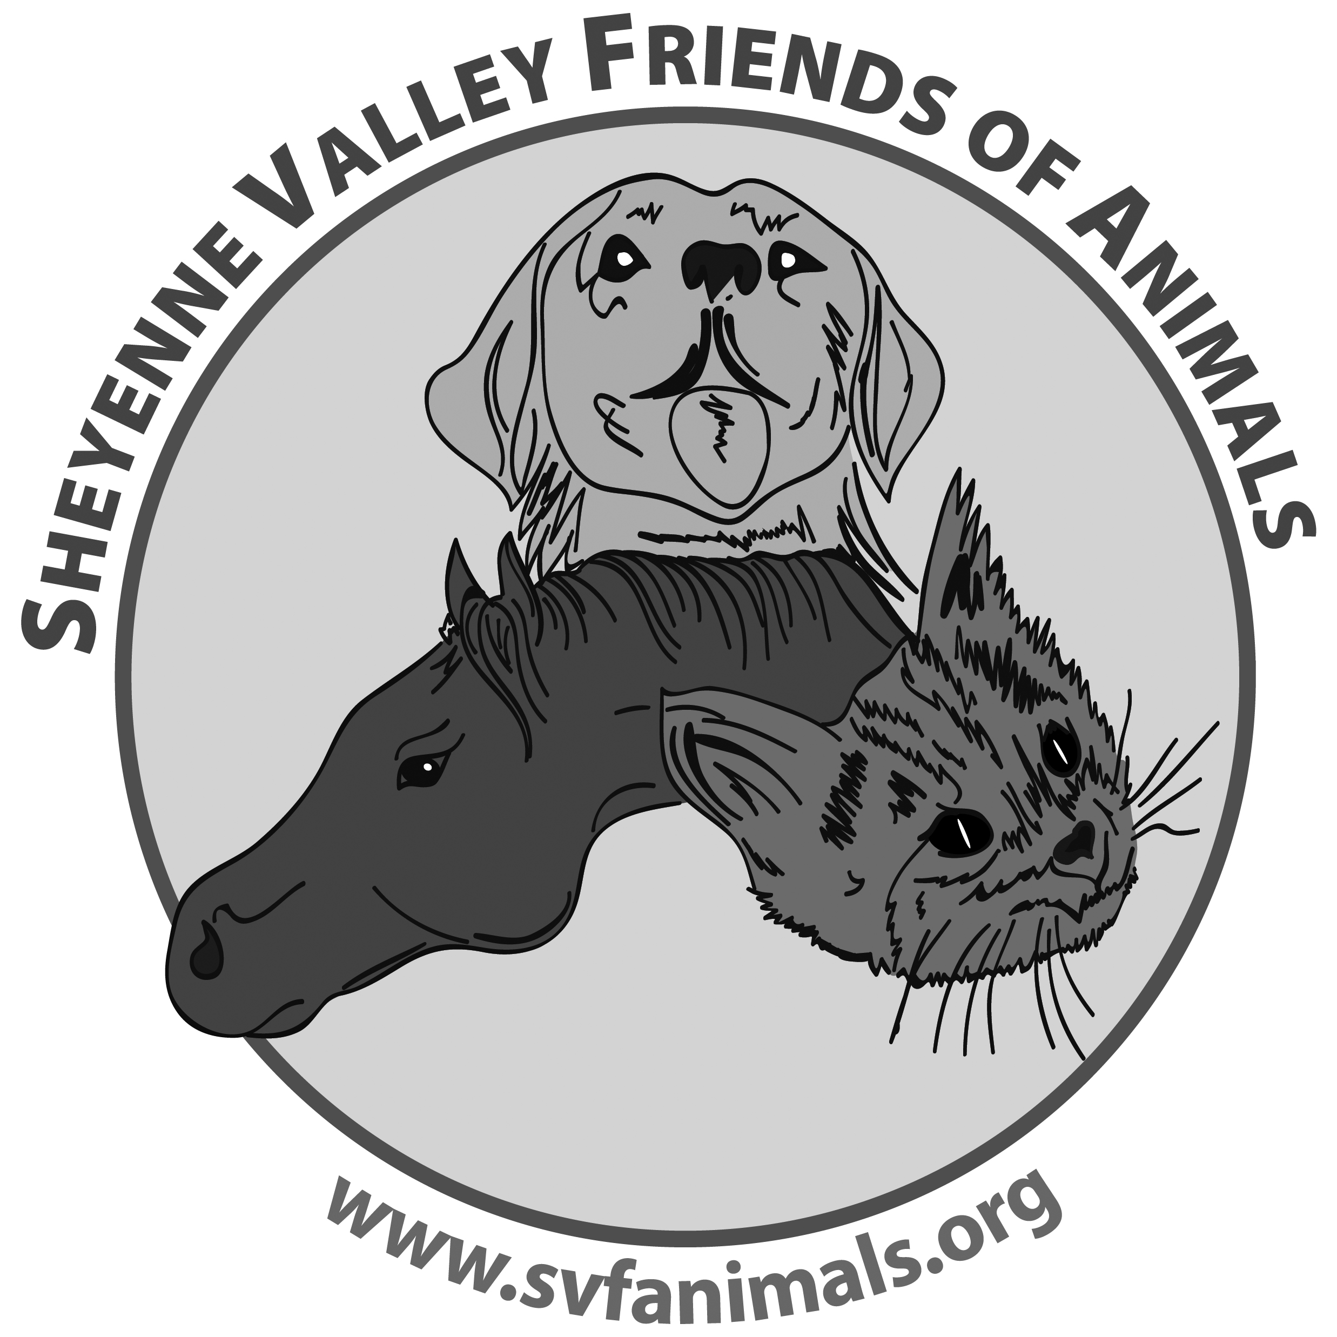 Foster Home Application______________

Name: _______________________________________________________

Street Address: ________________________________________________

City: ____________________ State: _____________ Zip: ___________

Phone: _________________ Cell Phone: __________________

Email: _______________________________________________

When is the best time to reach you? ________________________________

What is your preferred means of communication? Email ______ or phone _______

I am interested in fostering: (please check all that apply)

_____ Large Dog (adult) _____ Puppy (under 6 months) _____Puppy (over 6 months)
_____ Small Dog (adult) _____ Puppy (under 6 months) _____Puppy (over 6 months)
_____ Cat (Adult) _____ Kitten (under 6 months) _____ Kitten (over 6 months)
_____ Other (please specify) ________________________________

_____ I am willing to take in an animal with special needs (i.e. medical, deaf, blind, etc)
_____ I am willing to foster long term: mother & kitten _____ puppies ______

_____ I am willing to hold a foster animal over the weekend when the vet is unavailable. I have space where the animal will be kept separate from any other pets.

If you currently have any other pets at home, please list them: ________________
_______________________________________________________________________

Are they spayed or neutered? ___ Are they up to date with their vaccinations? ___

Do you have any animal care experience that you think would be useful as a foster volunteer? Please explain: _________________________________________________
________________________________________________________________________
________________________________________________________________________

Do you have children living at home? _______ Please list their ages: ______________

Do you ____ own or ____ rent your home? Is your yard fenced? _________________

Please describe the area where you will keep the foster pet when it is in your home: i.e. loose in the home, confined to certain room(s), in a crate:_______________________

______________________________________________________________________

Animals will not normally be placed in foster homes where they will be kept outside only.

Where will the foster pet stay when you are not at home? ________________________
_______________________________________________________________________

How many hours will the foster pet be alone during the day? ______________________

Who will be primarily responsible for the care of the foster pet? ___________________

Do you have any objections to an in-home visit prior to the application approval? ______

I am prepared to provide the foster pet with indoor shelter, social interaction and make a commitment to care for this animal until a permanent home can be found.

Signature:_________________________________________ Date: _______________
Please mail this form along with the liability release form to:
Sheyenne Valley Friends of Animals
P O Box 432, Valley City, ND 58072

Sheyenne Valley Friends of Animals
Foster Home Program

Liability Release

I understand that all SVFA animals have had wellness exams by a licensed veterinarian, are spayed or neutered (if old enough) and have had all routine shots.

I understand that although Sheyenne Valley Friends of Animals takes reasonable care to screen animals for foster care placement, it makes no guarantee relating to the animals' health, behavior or actions.
I received information concerning some but not all of the more common diseases associated with animals. Rabies is included in this information because of its severity and because SVFA does not know what diseases (including rabies) the animals might have been exposed to.

I understand that it is important to keep in contact with the SVFA foster home coordinator if I have any concerns regarding the health of animals I am fostering.

I understand that since many SVFA animals come from unknown backgrounds, no guarantee can be made concerning their health or temperament. Therefore, I release the Sheyenne Valley Friend of Animals from any responsibility regarding the health or temperament of the animals placed in my foster care.

Signature _______________________________________________________________

Date __________________________________________________________________

